**Eigenvalues and Eigenvectors**

Consider a square matrix n × n. If X is the non-trivial column vector solution of the matrix equation AX = λX, where λ is a scalar, then X is the eigenvector of matrix A and the corresponding value of λ is the eigenvalue of matrix A.

Suppose the matrix equation is written as A X – λ X = 0. Let I be the n × n identity matrix.

If I X is substituted by X in the equation above, we obtain A X – λ I X = 0.

The equation is rewritten as (A – λ I) X = 0.

The equation above consists of non-trivial solutions, if and only if, the [determinant value of the matrix](https://byjus.com/jee/determinants/) is 0.

The characteristic equation of A is Det (A – λ I) = 0.

‘A’ being an n × n matrix, if (A – λ I) is expanded, (A – λ I) will be the characteristic polynomial of A because it’s degree is n.

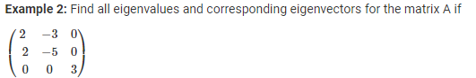

**Solution:**

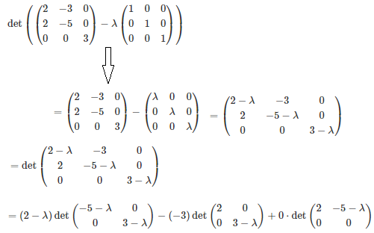

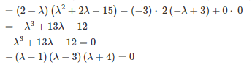



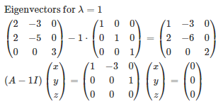

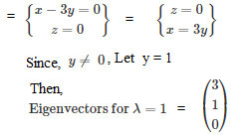

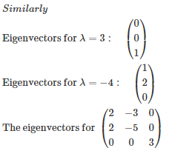

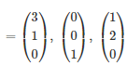

**Example 3:**Consider the matrix

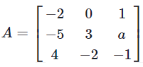

for some variable ‘a’. Find all values of ‘a’ which will prove that A has eigenvalues 0, 3, and −3.

**Solution:**

Let p (t) be the characteristic polynomial of A, i.e. let p (t) = det (A − tI) = 0. By expanding along the second column of A − tI, we can obtain the equation

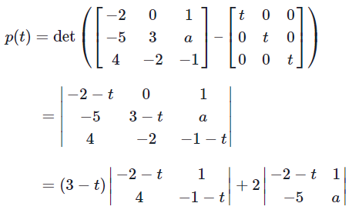

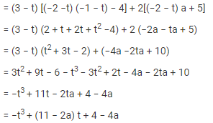

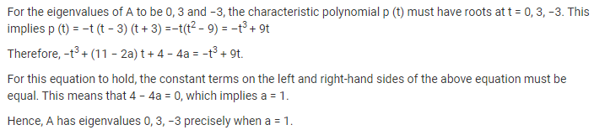

**Example 4:**Find the eigenvalues and eigenvectors of



**Solution:**

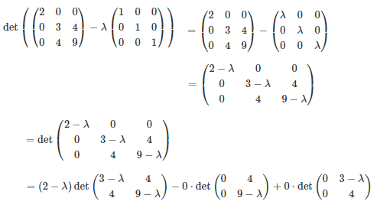

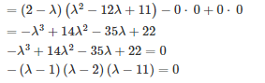



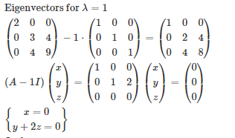

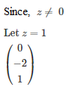



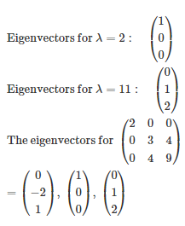

**Exercise**

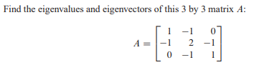

## ,

## See and practice:

## https://kanchiuniv.ac.in/coursematerials/Eigenvalues_and_Eigenvectors.pdf

## https://www.varsitytutors.com/linear_algebra-help/eigenvalues-and-eigenvectors?page=5

## Properties of Eigenvalues

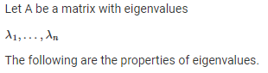

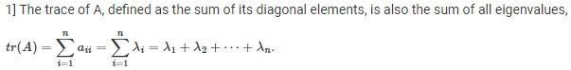

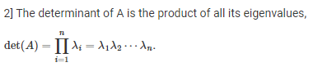

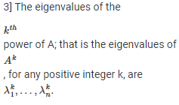



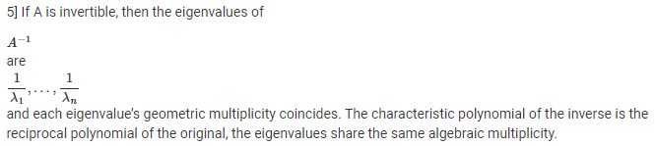

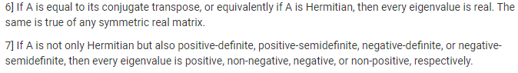

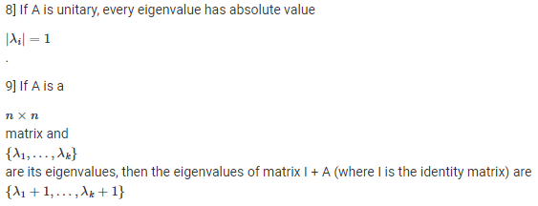

[**The Sarrus Rule**](https://www.nairaland.com/3663222/sarrus-rule-short-method-computing#54264201)

This method only works for 3×3 matrices. Given a matrix A of order 3×3.  
To apply Sarrus rule, copy the first and second column of A to form fourth and fifth columns. The determinant of A is then obtained by adding the products of the three “DOWNWARD DIAGONALS” and subtracting the products of the three “UPWARD DIAGONALS” as shown  
  
Thus, the determinant of 3 × 3 matrix A is given by the following  
a1b2c3 + b1c2a3 + c1a2b3 – a3b2c1 – b3c2 a1 – c3 a2 b1

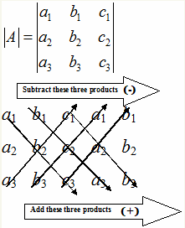

**Example:**

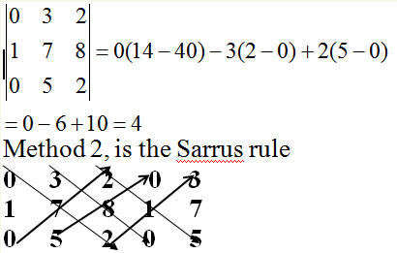

Multiply and add the elements of the corresponding arrows that go upwards:



Multiply and add the elements of the corresponding arrows that go downwards:



**Determinant:** Sum of lower arrows – sum of upper arrows = 10 – 6 = 4